**Roaming of automated testing**

**Version 1.0**

**Version History**

|  |  |  |  |
| --- | --- | --- | --- |
| **Version** | **Date** | **Handled by** | **Comments** |
| V1.0 | 17-May-2019 | ZL Chen | First version release. |
| V1.1 | 21-Sep-2019 | ZL Chen | Add the “Repeat Mode Setting.pdf”. |

Precondition Setting:

Please make sure the DUT is connected to the internet.

* Setting the User Account Control Setting.
  + Please refer to the “User Account Control Setting.pdf” attachment

(\automation\sop\User Account Control Setting)

* Install the Chrome browser.
  + Please refer to the “Chrome browser installation.pdf” attachment. (\automation\sop\Chrome browser installation.pdf)
* Install the Python 3.6.8.
  + Please refer to the “Python 3.6.8 installation.pdf” attachment.

(\automation\sop\Python 3.6.8 installation.pdf)

* Install the third party library.
  + Double click the “Envir_Install.exe” under the installer folder.

(\automation\installer\Envir_Install.exe)

* Setting the Repeat Mode.
  + Please refer to the “Repeat Mode Setting.pdf” attachment.

(\automation\sop\Repeat Mode Settting .pdf)

Please follow the implement as below:

Step 1:

Please make sure the Wi-Fi is connecting to the repeater.

SSID: siot_dqa

Password: ad20151225



Step 2:

Please delete all of the known networks, because you need make sure the network just only attach to the “siot_dqa” repeater.

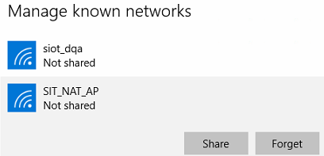

Step 3:

Please copy the roaming folder to the DUT’s desktop.

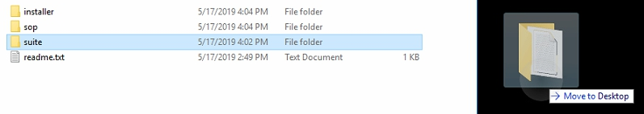

Implement the wifi_roaming.exe under the “\suite\roaming\” folder.

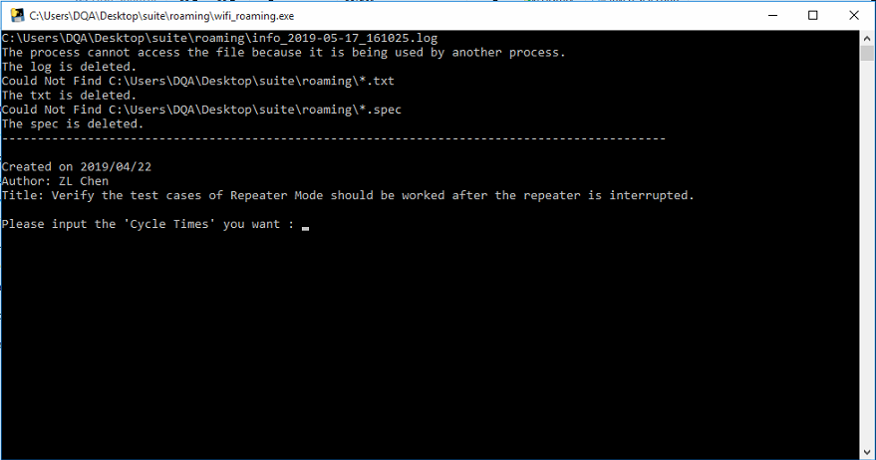

Step 4:

Please input the “Cycle Times” you want. (Ex: 1), and then tap the “Enter”.

The program is start running.

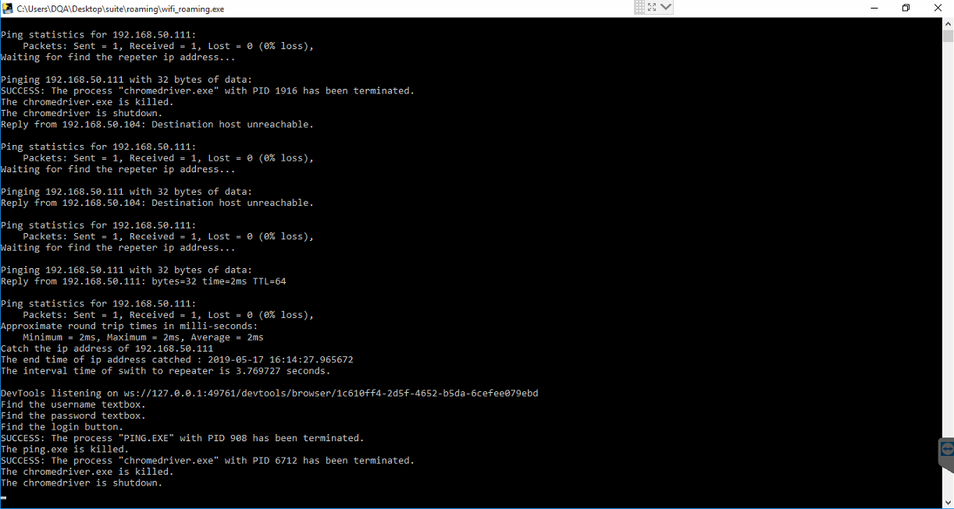

Step 5:

When the program is completed, the windows should be closed.

You can see the log under the “\roaming\” folder as below:

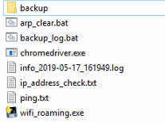

* info_2019-05-17_161949.log base on date and time.

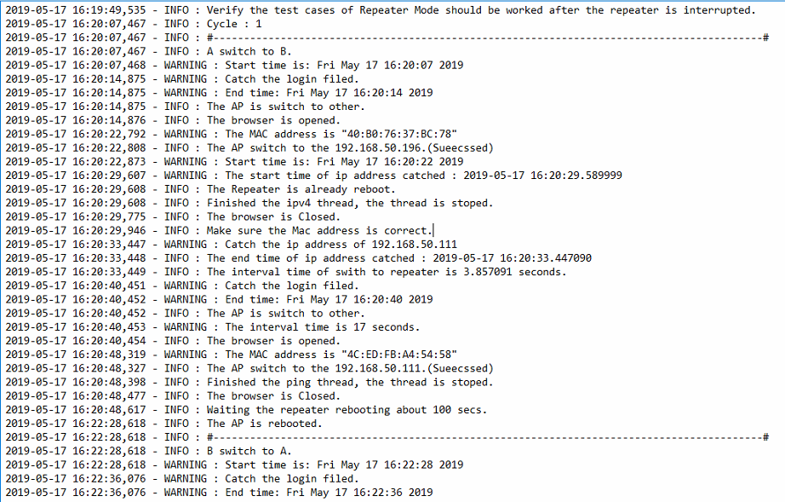

The interval time of switch to repeater is 3.857091 seconds. (A switch to B)

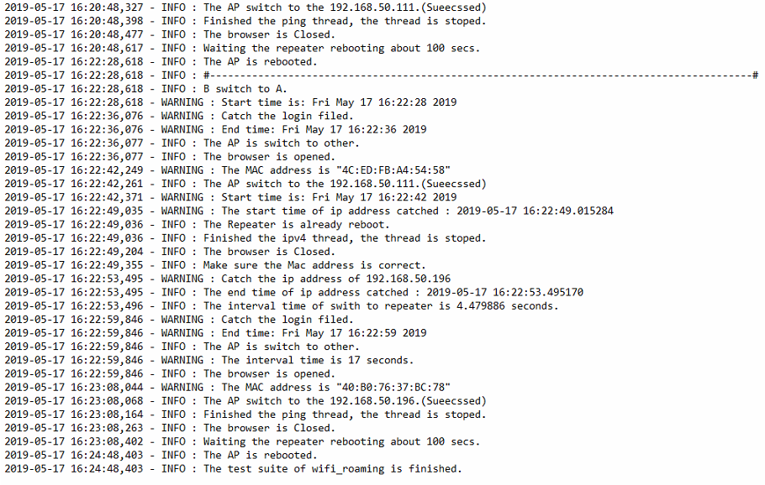

The interval time of switch to repeater is 4.479886 seconds. (B switch to A)

* ip_address_check is arp log.
* ping.txt is ping status.

